**BUILDING A CHATBOT USING PYTHON**

**SOFTWARE REQUIREMENTS:**

1. XAMPP

2. PYTHON IDLE (VERSION 3.9.6)

**MODULES USED:**

1. PYQT5

2. NLTK

3. TextBlob

4. PANDAS

5. MYSQL-CONNECTOR

**STEPS TO IMPLEMENT:**

**Step1**-Install XAMPP.

**Step2**- In background XAMPP needs to be running process.

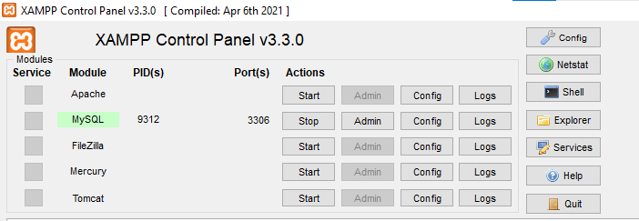

**Step3**- in XAMPP folder there will be a folder named MySQL that file location we will place in environmental variables

My File location: C:\Users\lenovo\Desktop\Xampp\mysql\bin

**Step4**- In environmental variables there are two places called user variables and system variables we need to select “PATH” from both variables

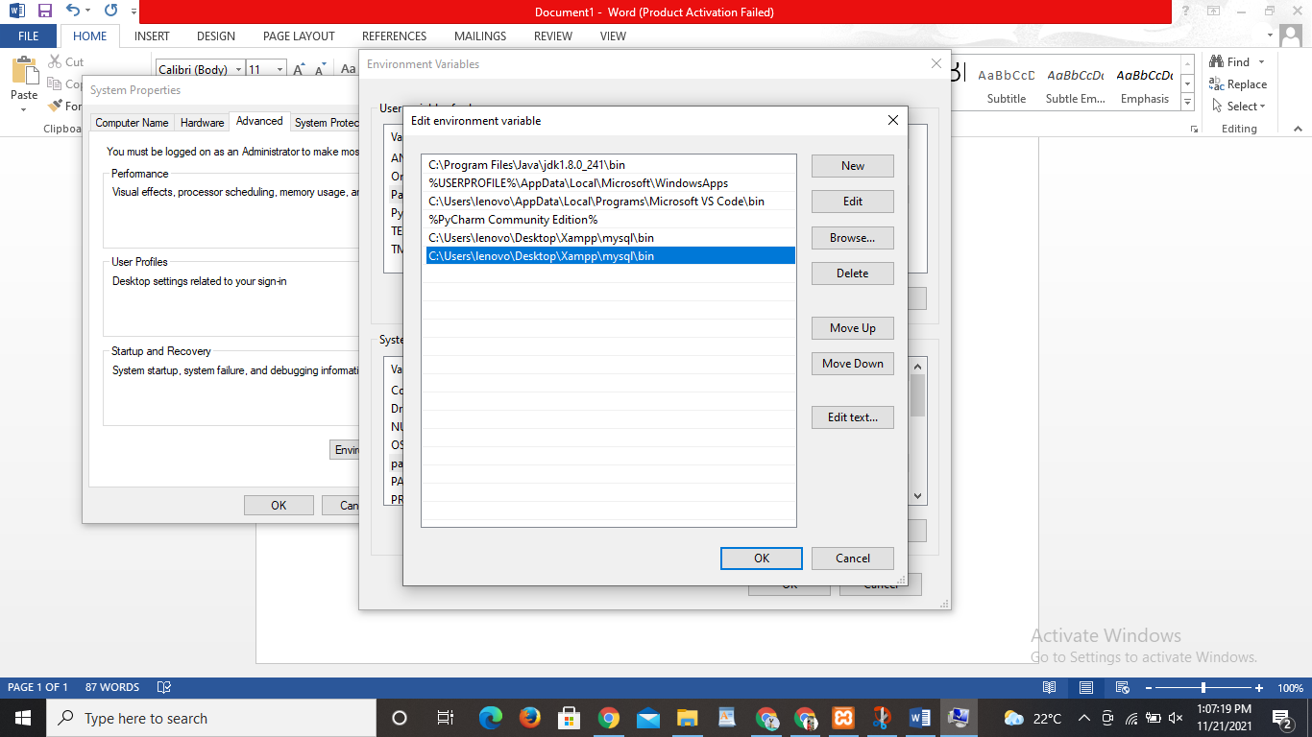 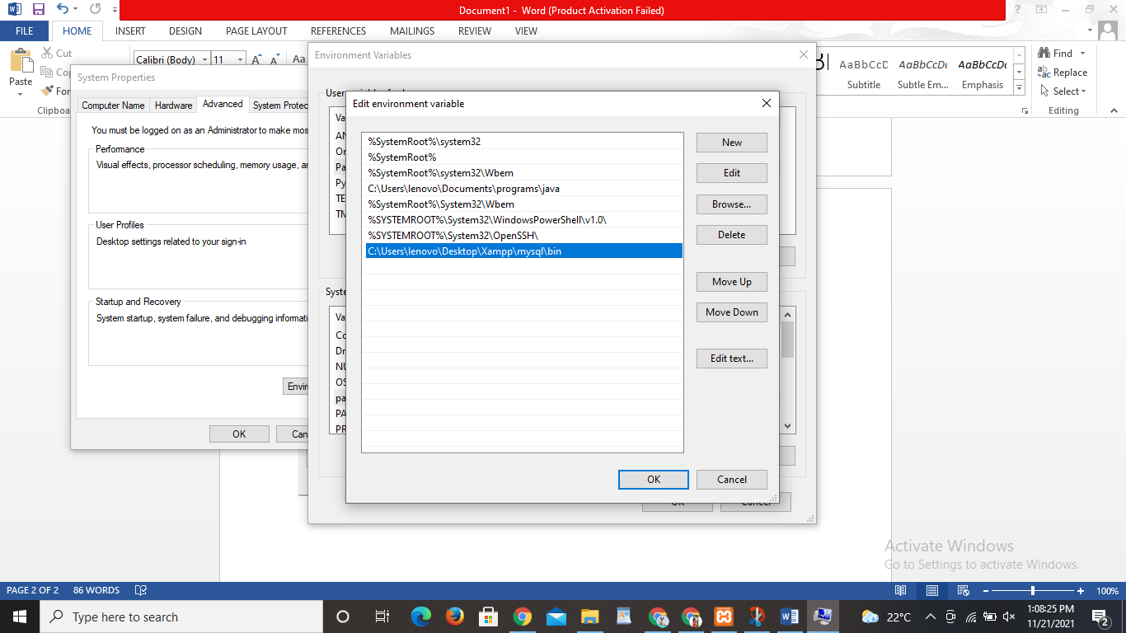

USER VARIABLE SYSTEM VARIABLE

**Step5**- Now the path is updated in Environmental Variables

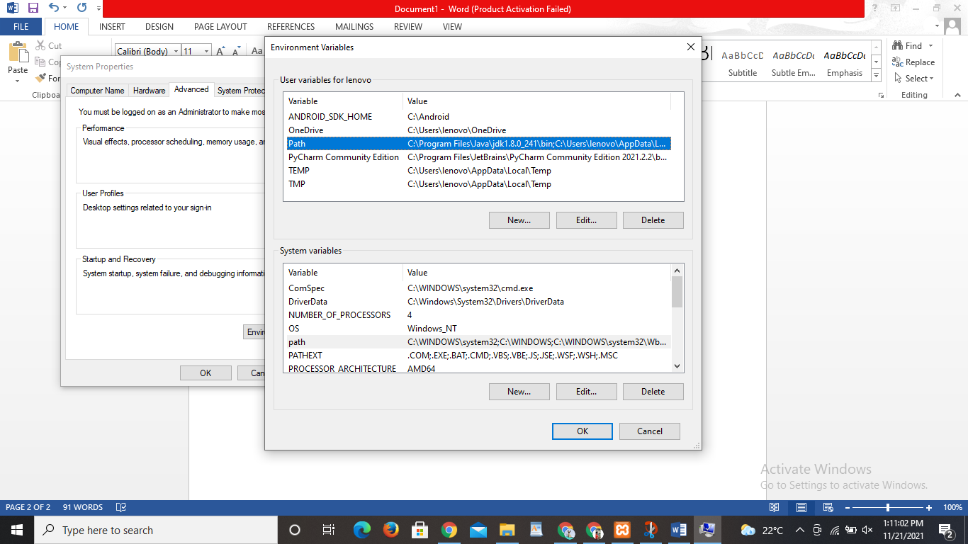

**Step6**- Now in command prompt we will place our file location

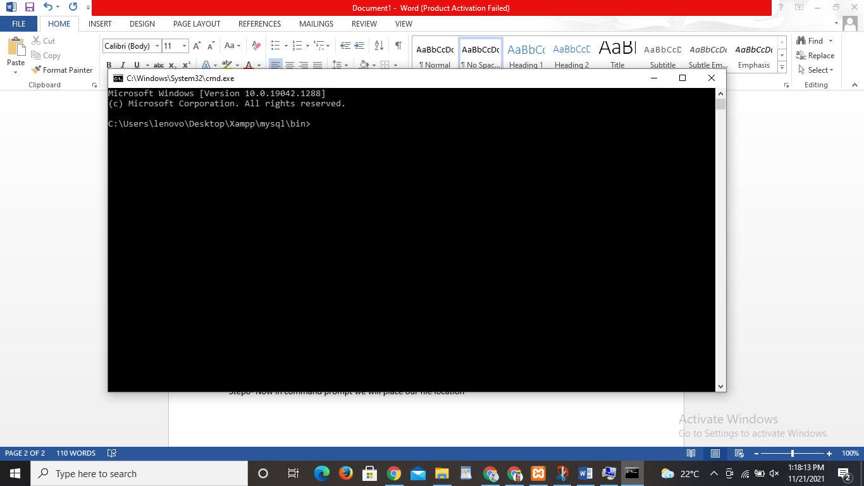

**Step7**- In command prompt type **MySQL -uroot.**

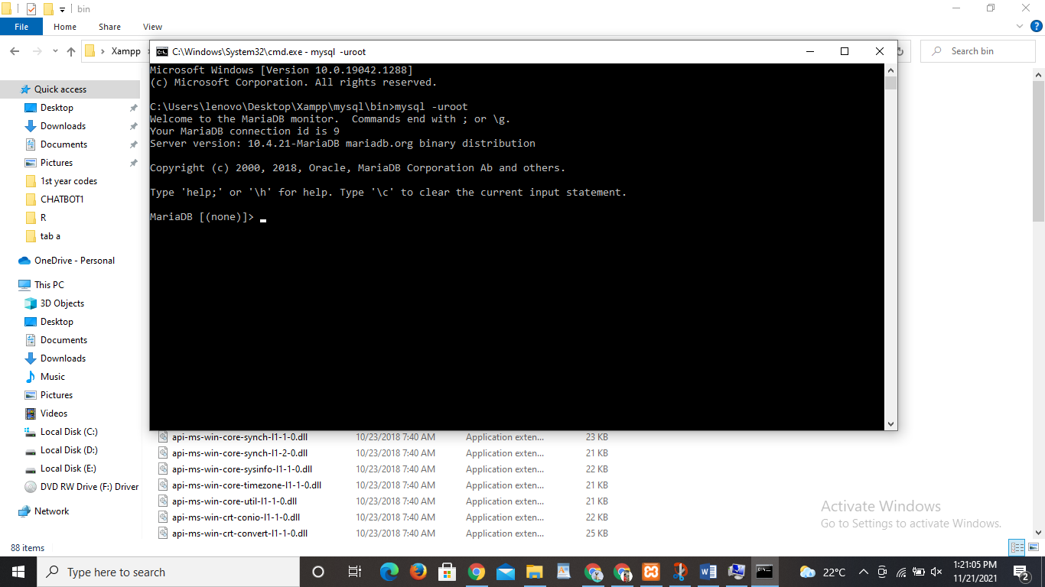

**Step8**- In command prompt type **show databases;** it shows the databases list which is present in MySQL

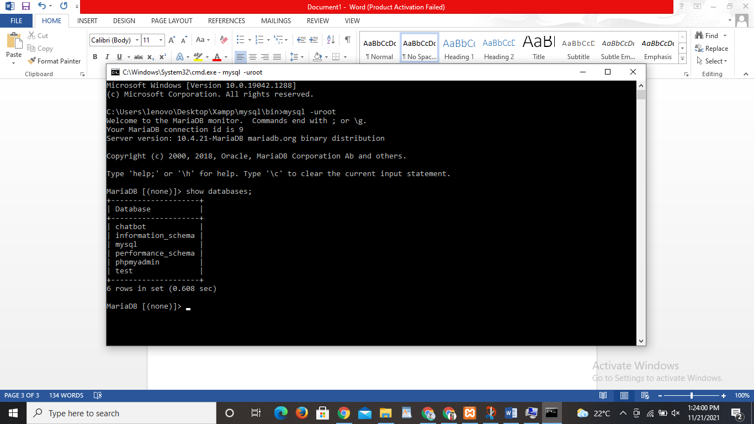

**Step9**- In command prompt type **use chatbot;** here the database changes as chatbot

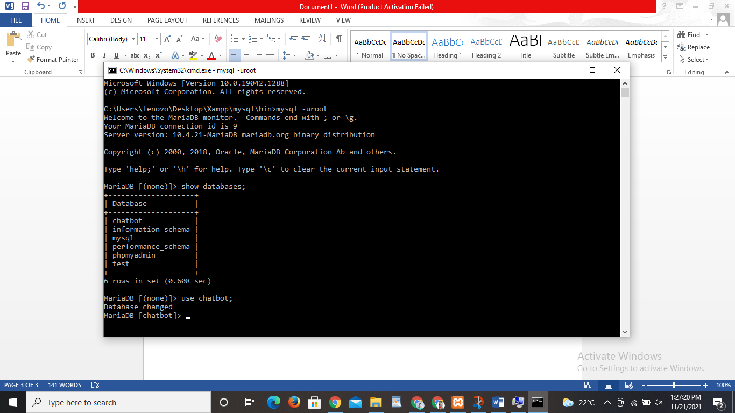

**Step10**- In command prompt type **select * from chatbot1;** here in command prompt we already described tables in our database chatbot

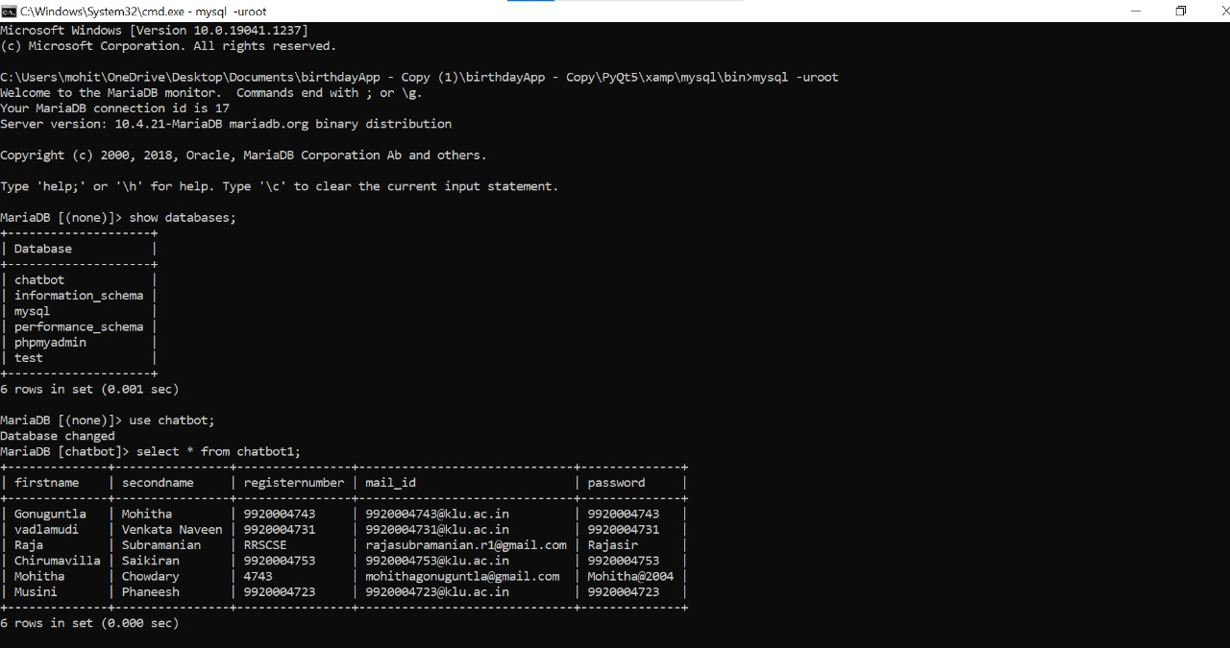

**Step11**- Now from the given python files select login11 after running the code you will be addressed to the login page

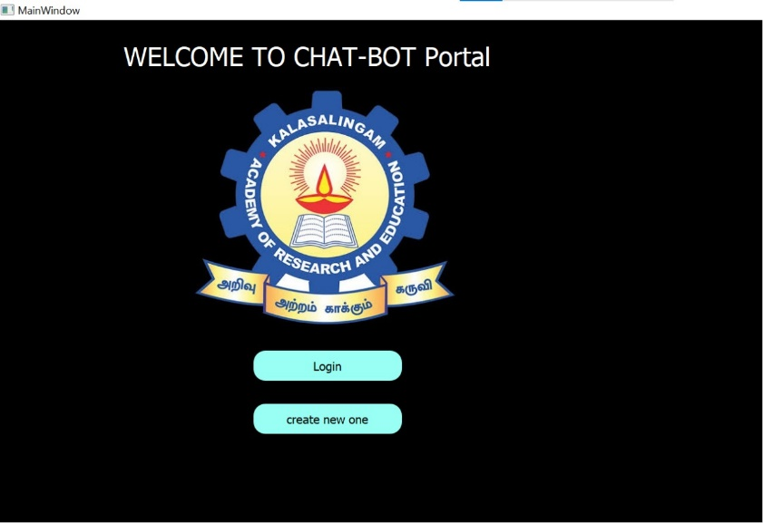

**Step 12**- For creating new account you needed to click create new one button for creating new account after that we needed to fill the details required for creating our account.

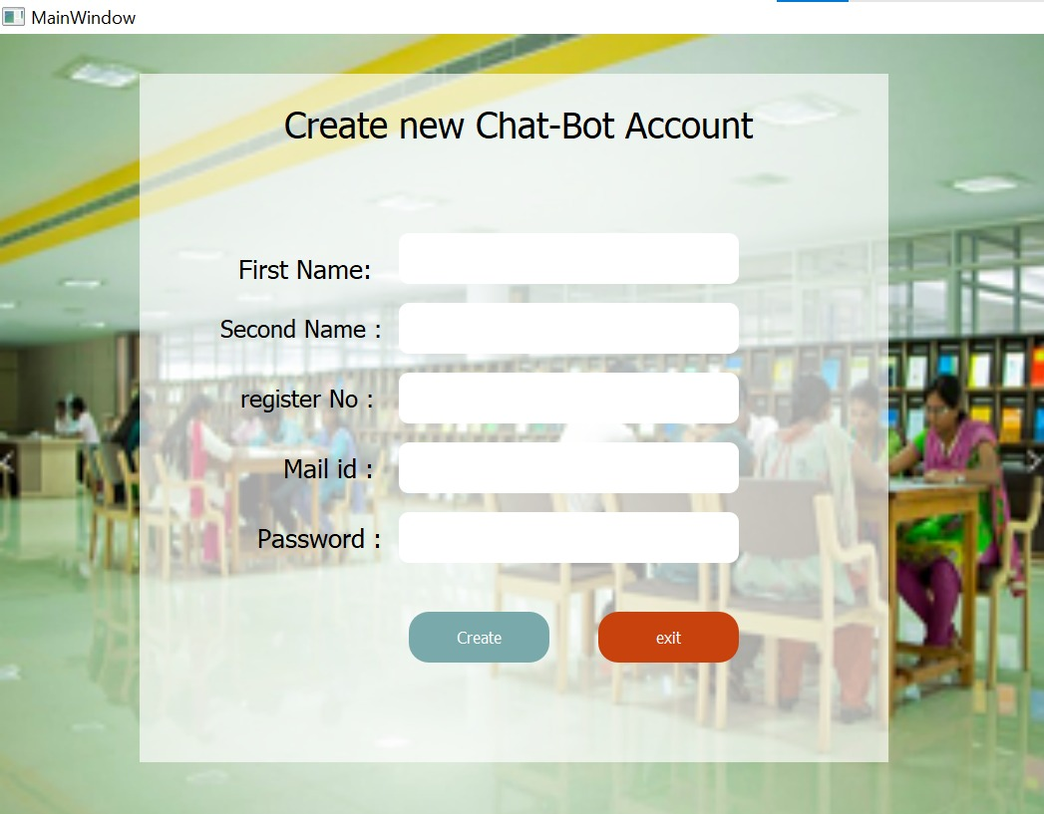

**Step 13**- Now you have a account for using our chatbot a new account is created now you can login using your created account

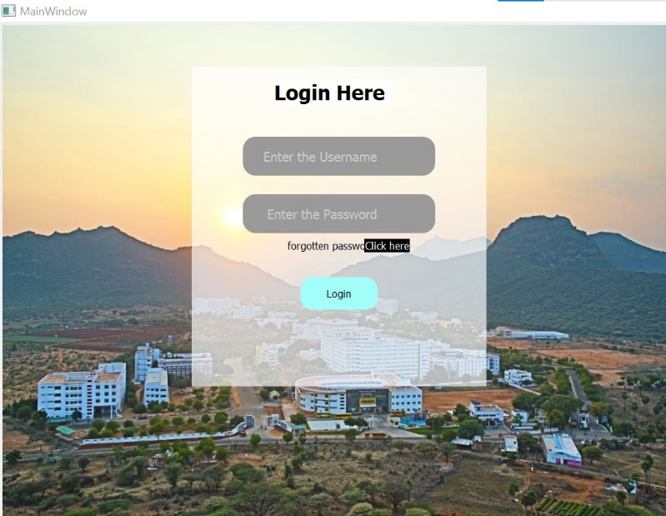

**Step 14**- if you forgot the password then you can click on forgot password to process further fill the details required for creating a new password hence the password is updated.

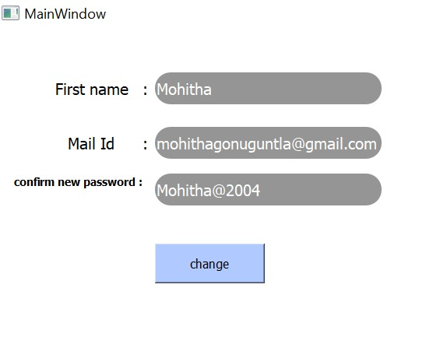

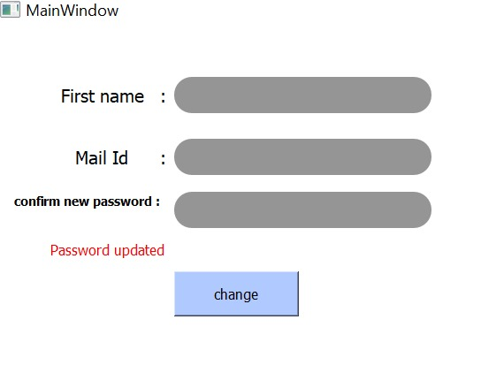

**Step 15**- Now you can login using your new password and text our chatbot. And here is a small conversation with our chatbot.

